PYTHON ACTIVITY BASED LEARNING
PROBLEM 5
Problem Statement:
Multi-Plan Telecommunications Cost Optimization: Evaluate several mobile plans against usage, validity, and budget constraints; calculate excess charges and identify the most economical eligible plan
1. Objective
To develop a Python program that compares multiple mobile plans based on data usage, call usage, validity, and budget constraints. The program calculates excess usage charges, determines the total cost of each plan, and identifies the most economical eligible plan.
2. Program (Python)
# Multi-Plan Telecommunications Cost Optimizationbudget = float(input("Enter your budget (Rs.): "))required_data = float(input("Enter required data (GB): "))required_validity = int(input("Enter required validity (days): "))required_calls = int(input("Enter required calls (minutes): "))plans = [ ["Plan A", 199, 1.5, 28, 300, 50, 0.50], ["Plan B", 299, 3.0, 56, 600, 100, 0.30], ["Plan C", 399, 5.0, 84, 1000, 150, 0.20]]eligible_plans = []print("\n--- Mobile Plan Comparison ---")for plan in plans: name, price, data, validity, calls, extra_data, extra_call = plan excess_data = max(0, required_data - data) excess_calls = max(0, required_calls - calls) extra_charge = (excess_data * extra_data + excess_calls * extra_call) total_cost = price + extra_charge print("\nPlan:", name) print("Base Price: Rs.", price) print("Excess Charges: Rs.", round(extra_charge, 2)) print("Total Cost: Rs.", round(total_cost, 2)) if (data >= required_data and validity >= required_validity and calls >= required_calls and
3. Algorithm
- Start.
- Input the user's budget, required data, validity, and call minutes.
- Store the details of multiple mobile plans.
- For each plan, calculate excess data and call usage.
- Calculate excess usage charges.
- Calculate the total cost by adding the base price and excess charges.
- Check whether the plan satisfies the data, validity, call, and budget requirements.
- Add eligible plans to the eligible list.
- Find the eligible plan with the lowest total cost.
- Display the most economical eligible plan or a message if no plan qualifies.
- Stop.
Flowchart
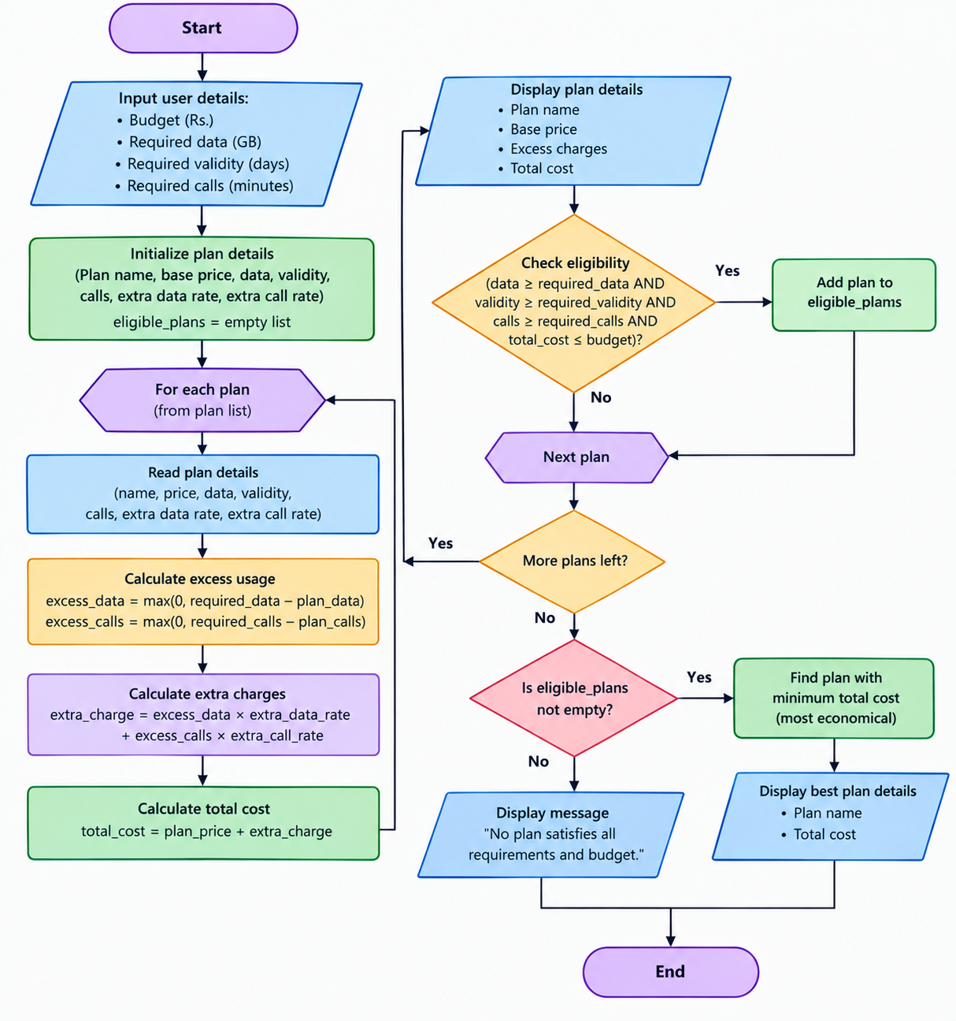
4. Pseudocode
BEGIN
INPUT budget, required_data
INPUT required_validity, required_calls

STORE mobile plan details
eligible_plans = empty list

FOR each plan
excess_data = MAX(0, required_data - plan_data)
excess_calls = MAX(0, required_calls - plan_calls)

extra_charge = excess_data * data_rate
+ excess_calls * call_rate

total_cost = plan_price + extra_charge

DISPLAY plan name, extra_charge, total_cost

IF plan_data >= required_data AND
plan_validity >= required_validity AND
plan_calls >= required_calls AND
total_cost <= budget THEN

ADD plan to eligible_plans
END IF
END FOR

IF eligible_plans is not empty THEN
best_plan = eligible plan with minimum total_cost
DISPLAY best_plan
ELSE
DISPLAY "No eligible plan found"
END IF
END
5. Sample Output
Example input: Budget ₹400, required data 2 GB, validity 28 days, and calls 400 minutes.
--- Mobile Plan Comparison ---

Plan: Plan A
Base Price: Rs. 199
Excess Charges: Rs. 50.0
Total Cost: Rs. 249.0

Plan: Plan B
Base Price: Rs. 299
Excess Charges: Rs. 0.0
Total Cost: Rs. 299.0

Plan: Plan C
Base Price: Rs. 399
Excess Charges: Rs. 0.0
Total Cost: Rs. 399.0

Most Economical Eligible Plan:
Plan: Plan B
Total Cost: Rs. 299.0
Result
The program compares mobile plans, calculates excess usage charges, checks usage and budget constraints, and identifies the most economical eligible plan.

